Abraham Ancer 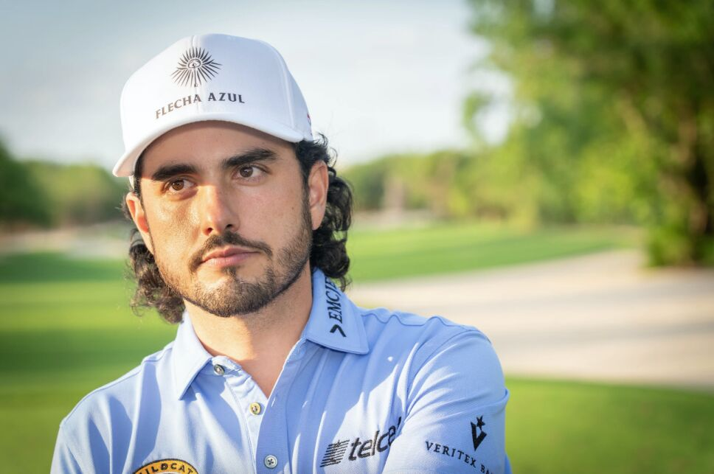
Sponsorships
- 2019-Present: Major Endorsement deal with Japan’s Muira Golf
Early Life and Amateur Career
- Born on February 27, 1991, in McAllen, Texas; raised partially in Reynosa, Mexico.
- Dual American and Mexican citizenship.
- Attended Sharyland High School, Mission, Texas.
- Played college golf at Odessa College and University of Oklahoma.
- Graduated from Oklahoma in 2013, degree in General Studies.
- First-team All-American at Odessa, tied for second in Junior College National Golf Championship.
- Won twice at Oklahoma, sixth-lowest scoring average (72.03) in university history.
- Second in all-time scoring average by the end of his college career.
Professional Career
Early Professional Years
- Turned professional in 2013, played on Web.com Tour in 2015.
- Won Nova Scotia Open in July 2015.
- Finished 11th in regular-season money list, earned PGA Tour card for 2016.
- Lost PGA Tour card for 2017.
- Five top-5 finishes in 2017 Web.com Tour, including three runner-ups.
- Regained PGA Tour card by finishing third in regular-season money list.
2018-2019 Seasons
- 9th at OHL Classic, 8th at Houston Open, 4th at Quicken Loans National, 5th at RBC Canadian Open in 2018.
- Earned $1.7 million, 60th in FedEx Cup.
- Top-5 finishes at CIMB Classic, Shriners Hospitals for Children Open in 2018-19.
- Won Australian Open, 5-stroke victory, entry into 2019 Open Championship.
- Tied for 21st at Tour Championship, earned $478,000 in FedEx Cup bonus money.
2019-2020
- Qualified for Presidents Cup International team.
- U.S. team won 16–14, Ancer's performance of 3–1–1 noted.
- Runner-up at RBC Heritage in 2020, led in Driving Accuracy and Greens In Regulation.
2021-Present
- Second at Wells Fargo Championship, May 2021.
- Won 2021 WGC-FedEx St. Jude Invitational, August 2021.
- Fourth Mexican player to win on PGA Tour, first to win on European Tour.
- Joined LIV Golf in June 2022, suspended from PGA Tour.
- Won team trophy in Bangkok, won PIF Saudi International on Asian Tour, February 2023.
Major Championship Performances 2017-2023
- 2017: Missed the cut in U.S. Open.
- 2018: Missed the cut in U.S. Open, T51 in The Open Championship.
- 2019: Made the cut in all four majors, T16 in U.S. Open.
- 2020: T14 at PGA Championship.
- 2021: Competed in all majors, T8 in the Masters.
- 2022: Consistent play, T12 at U.S. Open.
- 2023: Results not yet available.
Legacy and Achievements
- Career marked by perseverance and success.
- Won 2018 Emirates Australian Open, 2021 WGC-FedEx St. Jude Invitational.
- Symbol of success for American and Mexican golf.
- Characterized by accuracy and consistency.
Conclusion
- Synonymous with resilience, skill, success in professional golf.
- Journey from college star to professional winner.
- Victories across multiple tours, representation at international events.
- Significant figure in the sport, bright future.

